**TOBACCO VECTOR RESONANCE TEST (TVR)**

**April 2013 v1**



LEGAL NOTICE

*ASU30*

*ASU30 and ATUU30 are acronyms for Adult Smoker Under 30 and Adult Tobacco User Under 30. The term ‘adult’ is defined by local law, but shall in no circumstance refer to any person under the age of 18. Likewise, consistent with BAT’s International Marketing Standards, terms such as ‘consumer’, ‘target consumer’, ‘smoker’, or ‘target audience’ refer only to smokers whom are adults.*

LOCAL LEGISLATION / REGULATIONS

*The material contained in this document may present executions and themes that are not legally permissible or acceptable in some markets. Likewise, because tobacco regulation and the company’s own views on socially responsible marketing change over time, previously approved activities may no longer be permissible. Therefore, you must obtain local legal and CORA approval before proceeding with any activity in your market.*

*COPYRIGHT AND CONFIDENTIALITY*

*© British-American Tobacco (Holdings) Limited 2013. All rights reserved. No part of this document may be reproduced in any form or any means without the prior written consent of British-American Tobacco (Holdings) Limited (˝BAT˝).*

*This document is proprietary to BAT and is provided to employees of the BAT Group and certain trusted contractors working for a member of the BAT Group. It is disclosed solely for use by employees in the course of their employment or by contractors for the purpose of facilitating the provision of services by that contractor to the employing BAT company and for no other purposes. Unauthorized possession or use of this material or disclosure of the proprietary information without the prior written consent of BAT may result in legal action.*

*THIRD PARTY TRADEMARKS*

*“Trademarks, logo designs and/or brand names featured in this material and not owned by British American Tobacco PLC (or one of its group companies) are owned by the relevant proprietor of the particular trademark and/or brand name in question, and are referred to in this document for informational and/or illustrative purposes only.”*

Contents

2. Overview - Tobacco Vector Resonance Test 4

3. How to setup a TVR? 6

3.1 Research Design 6

3.2 Sample Size & Type 7

3.3 Rules around Target Group Setting 8

3.4 Stimulus materials and requirements 9

3.5 Product coding 10

3.6 Product handling 11

4. Interview and questionnaire flow 12

4.1 Visit and Interview flow 12

4.2 Questionnaire Flow 15

4.3 SAS+ attributes – local translation and validation 16

4.4 Questionnaire length: 16

5. Key Metrics and Analytics 17

5.1 Determining the size of lovers 17

5.2 Preference drivers 18

5.3 Reasons for likeability & rejection 18

5.4 Impact of familiarity 18

5.5 Environments association 19

5.6 Visualizing the extent of differentiation 19

5.7 Prioritizing amongst the vectors 20

5.8 Action Standard Setting 20

6. Agency for TVR 20

# Overview - Tobacco Vector Resonance Test

With the end goal of developing innovative products and differentiated brands, BAT has begun moving towards a more consumer centric, forward thinking and globally integrated business model. This vision centres on delighting consumers with differentiated product experiences.

In this light understanding the consumer preferences for products, tastes and flavours becomes critical. The Tobacco Vector Resonance Test has been developed as a new strategic tool to identify the potential taste territories & blending opportunities in the markets.

The Tobacco Vector Resonance Test is designed to test the 12 taste exemplars developed by the Global leaf and blending team. Please note that TVR does not test current products in the market but is specifically designed for these special samples.

These 12 products are based on 4 different types of taste vectors *(Aromatic, Bright, Dark and Earthy)*. Within each Taste vector, there are three different taste signatures –total of 12 different products developed. The chart below represents the taste/Flavour vectors i.e. 4 tobacco types and the 3 different taste types within each.

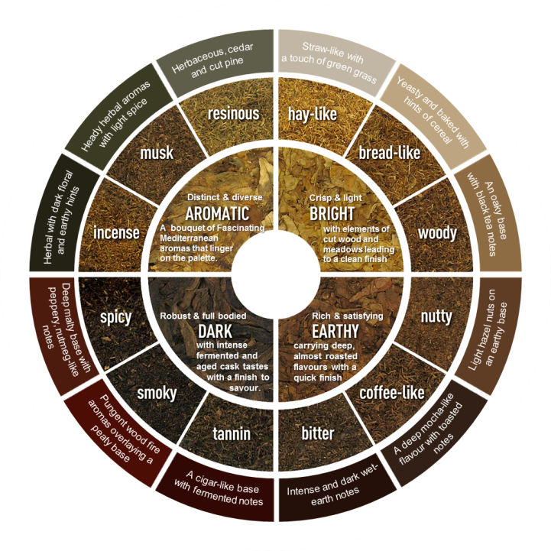

The 12 exemplars represent all the different tobacco types that BAT is currently using for blending. Understanding the taste preferences in a given market will help the product developers to design blends that are suited to consumer tastes and to identify new opportunities.

The Tobacco Vector Resonance Test (TVR) will use these 12 differentiated taste signatures to:

1. **Uncover promising taste territories** to inspire (differentiated) product development
2. Quantify **share of lovers**
3. Enable blend & flavor **signature development**
4. Understand vectors in the context **of consumer moments**

TVR is recommended to be done in the T15 and key Global Focus Markets every three years to help to formulate the product strategy. In addition it can be used when needed to aid product development.

Please note that the samples for TVR have a long lead time and they need to be agreed and booked in advance with your RPC.

The product testing plans are governed by the GPSG and the Regional Product Groups.

Any TVR test will require the sign-off from Global Oracle Manager.

# How to setup a TVR?

TVR is a quantitative product testing methodology where we place each product with the respondents for 1 day home placement. The products are placed in an un-branded format, in white test packaging without any branding information or elements. The TVR mirrors the principle of an Unbranded Product Test by capturing a pure product read (without any brand influence).

# Research Design

TVR is setup as a sequential monadic placement of the 12 products. The key difference to a normal Unbranded Product Test (UPT) is the length of placement being only 1 day (instead of 4 days). The reason for the 1 day placement is that these products are very differentiated and distinct flavours and they are not meant for longer consumption. It will be easy for the consumers to tell us which ones they like or dislike. Longer consumption might be over-whelming as well as some unnecessary adjustment might happen over time.

Each respondent will smoke all the 12 products in a pre-defined placement sequence:

* The 12 test vectors will be placed in 3 stages and in each stage the 4 vectors will be evaluated.
* The 4 vectors placed in each stage will belong to different tobacco quadrants *(Bright, Earthy, Dark and Aromatic)* – i.e. taste options belonging to the same tobacco quadrant will not be placed sequentially.
* There will be a 2 day gap between each stage to reset the taste pallet of the respondents, given that these samples are highly differentiated.
* In order to ensure a balanced placement – a specialized placement design will be used *(given the requirement to have successive placements from different tobacco vectors)*

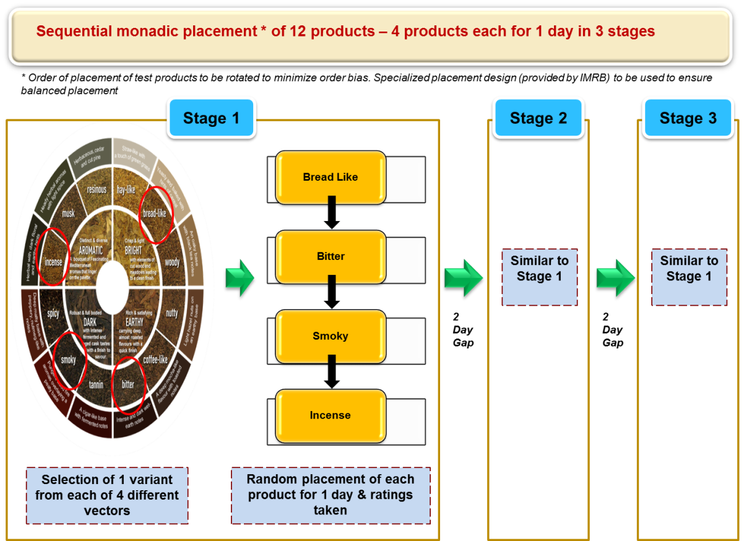

# Sample Size & Type

TVR is a strategic tool to understand the taste preferences within the market. The recommended approach is to split the market into meaningful product segments – such as KS FF, KS Lts, and Slims etc. and to cover the full spectrum of the consumers within them. If required it is possible to target specific segments, brands or demographic groups.

The sample size requirements are as follows

* + Minimum sample per panel is 250 smokers.
  + For any sub-group level reporting, minimum sample size of 150 is required. *For example, if a separate read is required among ASU 30 smokers, minimum sample size of 150 will be required for ASU 30.*
  + For each brand/ brand group which will be a part of the target group, a minimum sample size of 25 is required.

*Note: Reporting will not be done at a brand level.*

* For individual brand level reporting minimum sample size is 150

In terms of coverage, urban coverage is recommended with selection of key cities in the market. The key cities should be selected in such way that they represent the target segment effectively.

# Rules around Target Group Setting

Target group selection can be done at two levels:

**Overall product segment level**: Here the product segment will be decided on the basis of relevant tar x flavor x barrel specification

*For example if key BAT brand in a market is Dunhill Lts –the target segment will be smokers of Non-Menthol / Lights / Regular barrel. Similarly, if key brand is Kent Nano 6mg, the relevant target segment would be Non-Menthol / Lights / Super-Slims.*

The target brands should represent at least 80% of the relevant segment in order to be considered representative.

**Individual brand level**: Here the target group will be restricted to regular smokers of a particular individual brand.

# Stimulus materials and requirements

TVR test requires the following non-branded materials:

* White packs – with test codes
* Un-branded sticks

Amount of unbranded stimulus materials needed:

* Special vector samples for the 12 vectors
* Each test product will be needed for 1 day placement
* Number of packs placed per test offer depend on the Maximum Daily Consumption of the respondent
* We should always reserve an extra buffer of 10% for each test product

*For Example: Average Daily Consumption of target group is 19.8 sticks per day. Sample size is 250 smokers. The amount of products needed for each test product: 19.8 x 250 = 4950 sticks – divided by 20 to get 248 packs.*

*Additional buffer of 10% added to this – 248 packs x 1.1 = 279 packs.*

*As we can only include full packs it is good to also make the calculation the other way around to ensure enough products. If in doubt it is better to increase the buffer up to 15% rather than risk running short of products.*

Apart from the unbranded materials a TVR study also requires the Tobacco Taste Wheel and Environment show cards. Please note that these materials will need to be translated to the local language.

Please note that the lead time to order the special vector samples may be several months. The products need to be agreed with the RPC and the Global Product team. Therefore it is very important that before engaging with the research agency about the TVR – the availability and feasibility of the samples is clarified internally.

# Product coding

It is most important that possible biases attributable to different coding effects are minimised. Codes should be constant per product but designed to minimise bias effects. To achieve this, the following rules apply:

* All codes should be alpha-numeric and use one letter and 3 numbers (e.g. **D845**)
* Extreme letters of alphabet and extreme numbers of the 0-9 range should be avoided (e.g. **Z910, A091**). In effect this means avoidance of **A, B, C, X, Y, Z** and **O, 1, 8, 9**.
* Repetition of numbers should not occur (e.g. **X224, T333**).
* Occurrence of odd and even numbers should be balanced as much as possible (e.g. **S346**, **J627**).
* Sum value of each 3 number sequence should be relatively balanced (e.g. **P384**, **F825**).
* Where the first number of the code is greater for one code than the other, this should be offset with the order of occurrence of the letter part of the code in the alphabet (e.g. **R276, D843**). In this case, the further into the alphabet a letter is, the "heavier" it is, thus having the effect of adding more subjective weight to a low code start number.
* Sequences of rounded appearance letters and numbers and sequences of angular appearance letters and numbers should be avoided (e.g. **L471, Q386**).
* Codes with the first letter being equal to the first letter of the brand/product under research should be avoided (e.g. **M672 for Marlboro, D843 for Derby**).
* Sequenced 'runs' of letters and/or numbers should be avoided in multi-product evaluation (e.g. **A234, B456, C678**).

An example of coding for four products to be tested simultaneously is:

|  |
| --- |
| **D843 vs. J672 vs. S347 vs. W275** |

Common sense should apply to coding choices, but if these rules are borne in mind, they will help to minimise any bias effects.

# Product handling

To maintain adequate conservation, the product should maintain a humidity of 60% (+/-2) and a temperature of 22C (+/-1). This requires that the product be stored in air conditioning, in environments that do not receive direct light or severe changes in temperature.

The transport of the product should be carried out in tightly sealed coolers thus avoiding exposure of the product to direct light and/or elevated temperatures for more than 10 minutes. It is preferable to transport the product in air conditioned vehicles.

The product should be transported in small quantities estimating the amount to be delivered daily and quantities should not be loaded above those which would not guarantee proper delivery and handling.

The supervisors and/or interviewers should ideally carry a thermal bag with the daily delivery, thus eliminating exposure of the product to the aforementioned situations.

The good physical quality of the product when received by the consumer has a high impact in its perception. Under no circumstance should the consumer be handed open packs or packs that have been damaged (dirty, torn or wrinkled).

The research/fieldwork agencies should under no circumstances change the codes, the product or the packaging, or have access to the product for private consumption, as well as not alter, change, or modify the delivery methodology of the test.

# Interview and questionnaire flow

TVR is a multi-visit test that is done with pre-recruited consumers. Typically the consumers are first recruited by using various methods and quota sampling.

Interviews are normally conducted at respondents home or chosen location.

The test products are given to the respondent always one product at a time and any excess products are collected back.

There will be 15 visits in all if all 12 taste exemplars are being tested.

# Visit and Interview flow

Each test product will be placed for smoking for 1 day only –extended placement is not recommended since it is not feasible for respondents to smoke such highly differentiated cigarettes for longer than a day.

On the day of the placement the respondent is asked to smoke only the test product.

After the respondent has smoked the test product for one day, he will be contacted the next day to get his feedback on his smoking experience of the test cigarette smoked the previous day.

After taking feedback on the first product (1 day after smoking), respondents will be placed the next test product to smoke, again for a period of 1 day.

After 1 day smoking of the second test product, respondent will be contacted again to get his feedback on the second product – post which the third test product will be placed for smoking

This way, respondent will be placed 4 cigarettes to smoke in four consecutive days.

After the respondents have smoked first 4 test products in first stage, there will be a break of 2 days. Since the exemplar products are ‘pure blends’, after continuous four days of placement a break period is mandatory to reset the taste pallet. During the 2 days the respondent should be smoking their usual regular brand.

After the 2 day gap the same process will be repeated for the next 4 products in stage 2 (selected from 4 different tobacco vectors).

After completion of second stage, there will be again a break of 2 days, post which the last 4 products will be placed in a similar fashion

## 

**Process Summary:**

|  |  |  |  |  |  |
| --- | --- | --- | --- | --- | --- |
| Visit 1 |  | * Regular brand rating * Placement of Test Product 1 | |  | Day 1 |
|  |  |  |  |  |  |
| Visit 2 |  | * Evaluation of Test Product 1 * Placement of Test Product 2 | |  | Day 2 |
|  |  |  |  |  |  |
| Visit 3 |  | * Evaluation of Test Product 2 * Placement of Test Product 3 | |  | Day 3 |
|  |  |  |  |  |  |
| Visit 4 |  | * Evaluation of Test Product 3 * Placement of Test Product 4 | |  | Day 4 |
|  |  |  |  |  |  |
| Visit 5 |  | * Evaluation of Test Product 4 | |  | Day 5 |
|  |  |  |  |  |  |
|  |  | * **2 Days Break** | |  | **Day 5-6** |
|  |  |  |  |  |  |
| Visit 6 |  | * Placement of Test Product 5 | |  | Day 7 |
|  |  |  |  |  |  |
| Visit 7 |  | * Evaluation of Test Product 5 * Placement of Test Product 6 | |  | Day 8 |
|  |  |  |  |  |  |
| Visit 8 |  | * Evaluation of Test Product 6 * Placement of Test Product 7 | |  | Day 9 |
|  |  |  |  |  |  |
| Visits 9 |  | * Evaluation of Test Product 7 * Placement of Test Product 8 | |  | Day 10 |
|  |  |  |  |  |  |
| Visit 10 |  | * Evaluation of Test Product 8 | |  | Day 11 |
|  |  |  |  |  |  |
|  |  | * **2 Days Break** | |  | **Day 11-12** |
|  |  |  |  |  |  |
| Visit 11 |  | * Placement of Test Product 9 | |  | Day 13 |
|  |  |  |  |  |  |
| Visit 12 |  | * Evaluation of Test Product 9 * Placement of Test Product 10 | |  | Day 14 |
|  |  |  |  |  |  |
| Visit 13 |  | * Evaluation of Test Product 10 * Placement of Test Product 11 | |  | Day 15 |
|  |  |  |  |  |  |
| Visit 14 |  | * Evaluation of Test Product 11 * Placement of Test Product 12 | |  | Day 16 |
|  |  |  |  |  |  |
| Visit 15 |  | * Evaluation of Test Product 12 | |  | Day 17 |
|  |  |  | |  |  |
| **15 VISITS** |  | **TOTAL 12 PRODUCTS PLACED & EVALUATED** | |  | **TOTAL 17 DAYS** |

# 

# Questionnaire Flow

**VISIT 1**

|  |
| --- |
| **REGULAR BRAND EVALUATION** |
| New SAS+ attributes and OL from memory |
| Environmental association |
| Open-ended environmental association explanation |
| **TEST PRODUCT PLACEMENT** |

PLACEMENT FOR 1 DAY

**VISIT 2**

|  |
| --- |
| **POST SMOKING – RATINGS OF THE OFFER PLACED** |
| Purchase intent |
| Taste likes/dislikes – Open ended |
| New SAS+ attributes and OL evaluation |
| Taste familiarity |
| Environmental association |
| Open-ended environmental association explanation |
| Taste family and type association |

**VISIT 3, 4, 5… – Similar to Visit 2**

**SAS Attributes:**

Since the exemplars being tested are highly differentiated, the SAS attributes list that we use is a truncated version of the conventional Product Testing questionnaire. The attributes captured in TVR are:

* Draw Effort – *Just Right Scale*
* Intensity of Kick/Hit - *Just Right Scale*
* Sensation in Throat – *Magnitude Scale*
* Taste Quality - *Magnitude Scale*
* Taste Intensity - *Just Right Scale*
* Smell (while smoking) - *Magnitude Scale*

# SAS+ attributes – local translation and validation

The SAS attributes list used in TVR is a subset of the global SAS+ attribute list.

Whilst the global list has been defined and validated in English – before a market uses the list (or any new attribute) in a study the following two things need to be done:

1. **Translation of the attributes to local language(s).** The most important thing is to capture the meaning rather than try to translate directly from English word by word. Once you have translated into local language is very important to ask a third party to perform a “back-translation” to English to check that your local translation truly is reflective of the English attribute.
2. **Validation with local consumers**. The translated attribute list needs to be tested with consumers to check if they understand the attributes and their meaning in the way that we intended. There has to be a clarity what consumers understand when looking at the attributes.

Please make sure that the SAS+ list is properly translated and validated for your market. Never use an attribute in a TVR unless it is validated and it is clear how consumer understands it.

# Questionnaire length:

Each visit is about 15 - 20 minutes long.

# Key Metrics and Analytics

Key deliverables for a TVR research:

* *Determining the size of the Lovers*
* *Preference drivers*
* *Reasons for likeability and rejection*
* *Impact of familiarity*
* *Environment association*
* *Visualizing the extent of differentiation*
* *Prioritizing amongst the vectors*

# Determining the size of lovers

The 12 vectors will be evaluated in terms of the proportion of people truly liking each one. There will be two dimensions of likeability on which each vector will be evaluated on – Definite Lovers & Moderate Lovers.

A “**Definite lover**” is defined as someone having a wholesome smoking experience leading to positive purchase intention.

This definition of wholesome smoking experience will be based on product ratings on the most discriminating attributes* coupled with unambiguous positive Purchase Intent.

A “**Moderate lover**” has a wholesome smoking experience – however might or might not have a positive Purchase Intent. The idea is to capture a more inclusive definition taking into account both Regular as well as Occasional usage. This definition also will be based on product ratings on the most discriminating attributes*.

*\* The most discriminating attributes to be included in the Lovers Definition is to be determined using a chi square test wherein the discriminatory power of each attribute in explaining Overall Likeability is tested. Attributes with higher chi square value are considered more differentiating and therefore can be included in the Lovers definition.*

# Preference drivers

Once the size of “lovers” has been established, the next step as a diagnostic tool is to understand the preference drivers for Overall Likeability. This will be done by conducting SEM (Structural Equation Modeling) for each product based on ratings on SAS+ attributes for each product.

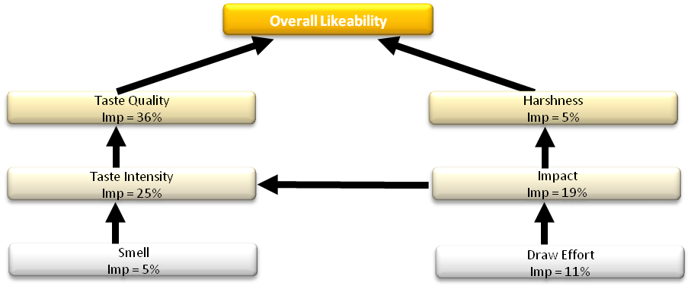

# Reasons for likeability & rejection

Once the overall preference drivers are found, further analysis will be done to segregate the reasons behind loving a vector vs. the reasons behind rejecting it. This is done by analyzing the ratings of the vector on the diagnostic sensory attributes among Lovers & Rejecters.

# Impact of familiarity

This section will analyze the relationship between familiarity/uniqueness of a vector vs. its likeability & rejection.

# Environments association

The Environment association section will allow mapping of each product / vector against the most associated smoking environment.

* 15 Smoking environments will be tested
* Respondents will be asked to associate the test product with 1 or more environments
* Then they will be asked to associate taste of test vector with a particular taste family & one of the 3 taste types within the selected taste family

# Visualizing the extent of differentiation

This analysis uses a technique called Multidimensional Scaling (MDS). A proximity measure between the vectors is calculated taking into account all SAS attributes. This proximity matrix is then visualised with the help of MDS.

The MDS will help us identify which taste vectors are perceived similar to each other and which taste vectors are truly differentiated in consumer perception.

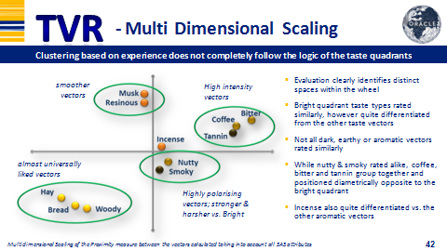

# Prioritizing amongst the vectors

* *TURF (Total Unduplicated Reach & Frequency)* gives the potential reach (i.e. the proportion of smokers who would be interested in the vector) or combination of vectors once it is launched
* The analysis provides a hierarchy of vectors in terms of reach that the vector can individually attain and also the incremental reach which a combination of multiple vectors can attain when they are launched
* The model adjusts the hierarchy of reach for a combination of vectors keeping in mind the possibility that there may be an overlap in terms of respondents who like both the vectors in the combination
* The results can help in the product strategy formulation and present the range of opportunities and their potential.

## 

# Action Standard Setting

Since the research is exploratory in nature, there are no set action standards. The results are used for product development.

# Agency for TVR

All TVR tests are coordinated and managed by IMRB International. Fieldwork can be conducted with the agency of choice as per the usual guidelines.